Look at the following aspects of the golf club:

1. **Club Head Size**

With the advent of MOI (moment of inertia) importance, this factor has become a big consideration, particularly with higher handicappers. When shots are struck outside the sweet spot, a high MOI reduces twisting at impact, delivering shots closer to the target area.

1. **Shaft Flex**

The shaft flex impacts things such as trajectory, accuracy, distance, and consistency. During the golf swing, the club "flexes" throughout until squarely meeting the ball at impact. An incorrect shaft flex significantly reduces the chance of making consistently solid contact.

1. **Shaft Weight**

Heavier shafts may be better for control, while lighter shafts may help with distance. At the same time, a short swing can produce the same speed as a long one if the shaft weight is better for the individual golfer's swing.

1. **Shaft Material**

Here, again, personal characteristics make the decision. The composition of steel and graphite shafts, their kick (or bend) points, swing weights and torque ratings are considerations

Among other things, shaft length will impact where on the clubface the ball is consistently struck. The correct shaft length will prevent a golfer from having to alter a natural swing arc in order to make an optimal impact.

1. **Length of the Club**

Among other things, shaft length will impact where on the clubface the ball is consistently struck. The correct shaft length will prevent a golfer from having to alter a natural swing arc in order to make an optimal impact.

This is very important on a couple of levels, one is that you want the proper length club so that you feel comfortable with it in your hand. You won't feel the need to choke up on the shaft or feel like you are reaching for the ball. The proper length of the club also lets the club maker assemble your club to have the correct flex in the shaft. If you choke up on the club you are in essence moving the kick point which in turn stiffens the shaft. Think of a telephone pole, when the pole is long, it can sway in the wind, cut it shorter and it is extremely stiff.

1. **Lie Angle**

This is the angle formed by the shaft and sole of the club. Having a correct lie angle will cause the center of the clubhead to touch the ground. If the toe of the clubhead is raised, a hooking shot may result. Should the heel be raised, a push or slice may result

1. **Grip Size**

The Size is the most important factor to consider when choosing a grip. The wrong size can affect the directional outcome of the shot. Too small a grip could promote pulling the ball, and too big a grip could promote a slice.

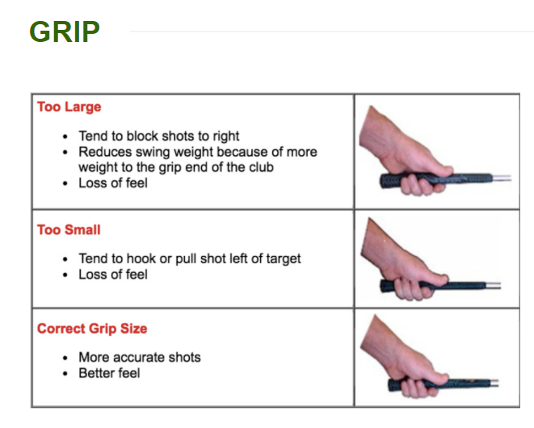

The right grip size can impact the golfer's ability to return the clubface to a square position and release the wrists through impact. Also, with the variety of grip compositions, personal preference is a determining factor

Club fitters should be able to give golfers personal attention and many often use technology in the form of launch monitors as one means of assessment.

A launch monitor typically measures clubhead speed, ball speed, launch angle, spin rate, carry distance and overall distance. Measuring these characteristics, along with others, will help the club fitter select the proper clubs for each golfer. Many golf shops will offer club fitting without requiring club purchase, albeit for a fee

By watching the ball flight produced by each variation of a club, and checking chalk marks left on adhesive strips attached to the clubface and sole, a club fitter can quickly narrow the search and lead the student to the best fit

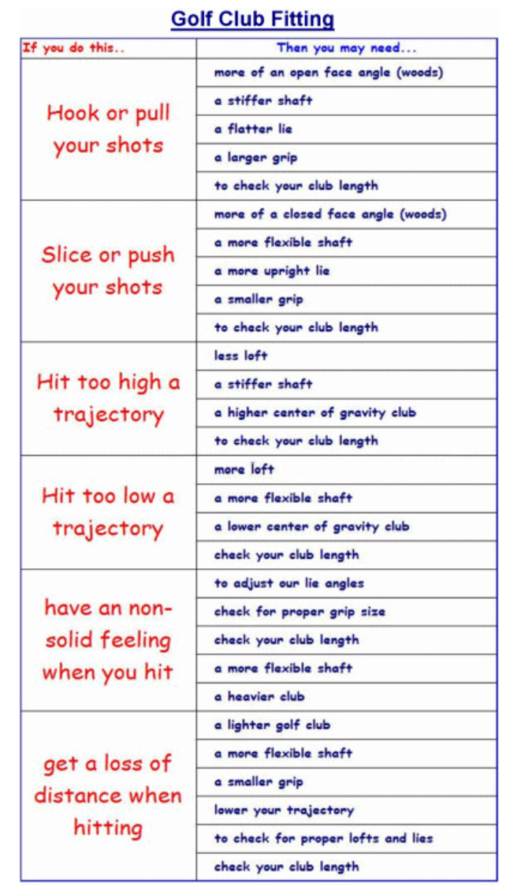

The Custom Fitting process is broken down into 2 distinct phases: Static and Dynamic. Some of the static measurements you can obtain yourself, but the dynamic fitting is where your natural form is analyzed under the keen eye of your skilled fitter to determine your clubs!